Lab 4 plus
*Lab 4 plus is a combination of Lab 4 and an extra activity on ARP.

Packet Tracer Simulation – Exploration of ARP and Switch Table Communications

Objectives
- To explore ARP and switching operations.
Introduction
The topology is given to you. All IP addresses have been assigned to all devices. Please follow each step in sequence.
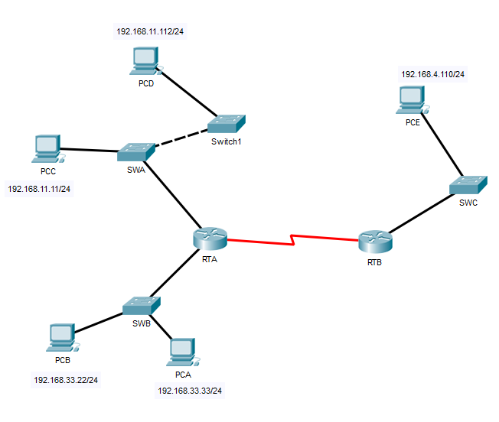
Figure 1

Part 1: Review the topology

Step 1: Perform the following tasks.
- At Router RTA, enter the CLI. At the command prompt type the following commands. Snap the results after the last command and paste it here.
RTA>enable

RTA#show arp

Answer Screenshot:

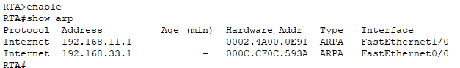

- At Router RTB, enter the CLI. At the command prompt type the commands as in Figure 2. Snap the results after the last command and paste it here.

Answer Screenshot:

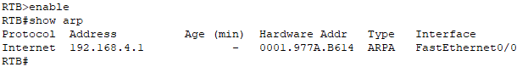
- At Switches SWA, SWAB and SWC, enter the CLI. At the command prompt type the following commands. Snap the results after the last command and paste it here.
SWA>enable

SWA#show arp

SWA#show mac-address-table

SWA | 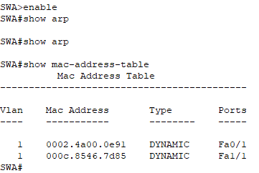
SWB | 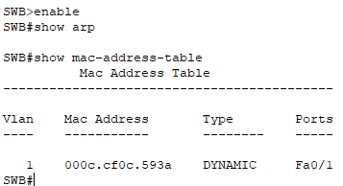
SWC | 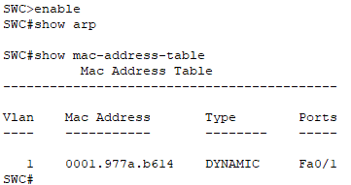

- At PCA, click on the PC icon, and then choose Desktop-Command Prompt. At the command prompt type arp –a and click enter. Snap the results after the last command and paste it here. Do this to all PCs in the topology.

PCA | 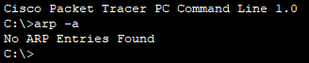
PCB | 
PCC | 
PCD | 
PCE | 

- What are your thoughts on the results?
No entry for all PCs as all the PCs did not receive any ARP request. There will be no entry in the PC’s ARP table.

Part 2: Generate Network Traffic

Step 1: Generate traffic between PCA and PCB.
In the command prompt Perform the following tasks task to reduce the amount of network traffic viewed in the simulation.
- Click PCA and click the Desktop tab > Command Prompt.
- Enter the ping 192.168.33.22 command. This may take a few seconds.

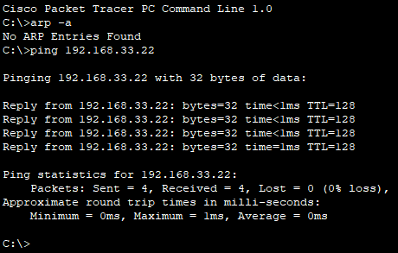

- In the Command prompt of PCA, type arp –a. Paste the result of this command here.

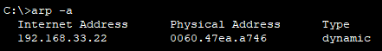

- In the Command prompt of PCB, type arp –a. Paste the result of this command here

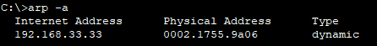

- In the Command prompt of PCC, PCD abd PCE, type arp –a. Paste the result of this command here.
PCC | 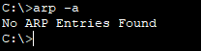
PCD | 
PCE | 

Step 2: Generate traffic between PCC to all other PC except PCA.
- Click PCC and click the Desktop tab > Command Prompt.
- Enter the ping 192.168.33.22 command (ping to PCB). Then type arp –a. Paste the result after these commands here.

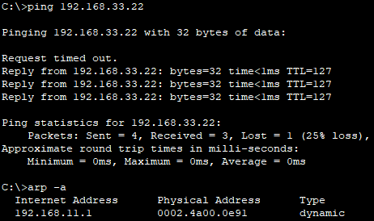
- Enter the ping 192.168.11.112 command (ping to PCD). Then type arp –a. Paste the result after these commands here
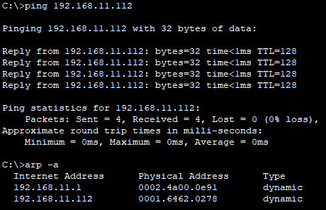
- Enter the ping 192.168.4.110 command (ping to PCE). Then type arp –a. Paste the result after these commands here.

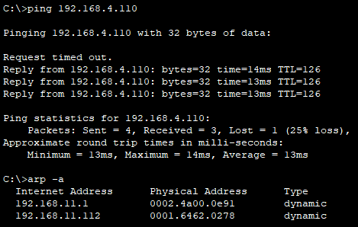

- Discuss the results you got from all the commands on PCC.
The ARP table shows the ARP entries only after PCC send pings to PCB, PCD, and PCE. Before ping activities, there are no ARP entries. The ARP table display entries once PCB, PCD and PCE receive ARP requests from PCC and then receive pings from PCB, PCD and PCE.

- At Router RTA, enter the CLI. At the command prompt type the following commands. Snap the results after the last command and paste it here.
RTA>enable

RTA#show arp

Answer Screenshot: 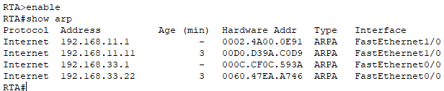
- At Router RTA, enter the CLI. At the command prompt type the following commands. Snap the results after the last command and paste it here.
RTB>enable

RTB#show arp
Answer Screenshot: 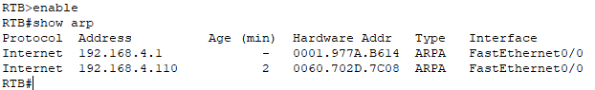

Step 3: Switch MAC address table.
- At Switch SWA, enter the CLI. At the command prompt type the following commands. Snap the results after the last command and paste it here.
SWA>enable

SWA#show arp

SWA#show mac-address-table
Answer Screenshot:
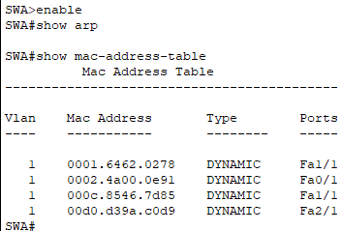
- At Switch SWB, enter the CLI. At the command prompt type the following commands. Snap the results after the last command and paste it here.
SWB>enable

SWB#show arp

SWB#show mac-address-table

Answer Screenshot:
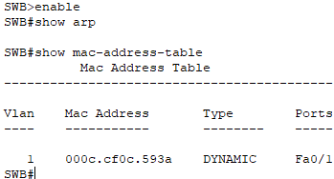

- At Switches SWC and Switch1, enter the CLI. At the command prompt type the following commands. Snap the results after the last command and paste it here.
SWC>enable

SWC#show arp

SWC#show mac-address-table
Answer Screenshot:
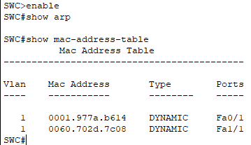
- Do switches use arp table? (Y/N)
Yes
- Explain your answer in (d) *Hint: the answer may surprise you. Google for the explanation. It is not part of NetComm syllabi, it is just for knowledge..
Switches use an ARP table to keep track of the IP addresses and matching MAC addresses of devices in the network. This table helps the switch find the right MAC addresses for communicating with other devices on the network.
- What information does the command show mac-address-table gives?
To see the MAC address table entries on a switch, the term "DYNAMIC" is used to show the MAC addresses that the switch has learned while it has been running.

Part 3: Attach wireless lab results.
In this part, you will use Lab 4 .pka file.
Step1: Change the filename of Lab 4.
- Change the Lab 4 filename to include your name. *Example: Lab4AliAhmad.pkt
- Go through the instructions. As you complete the tasks, you will see the bottom right hand corner of the pkt file increase in completion percentage, until you get 100/100.

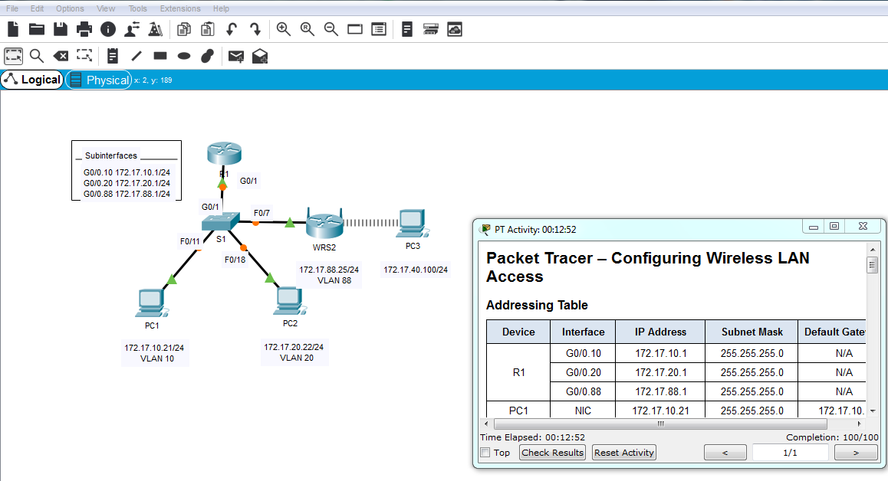
- Once you have completed fully, capture the screen (which includes the filename, the topology and the activity wizard showing completion) and paste it here.
filename: Lab4PohLokYee
Completion: 100/100
